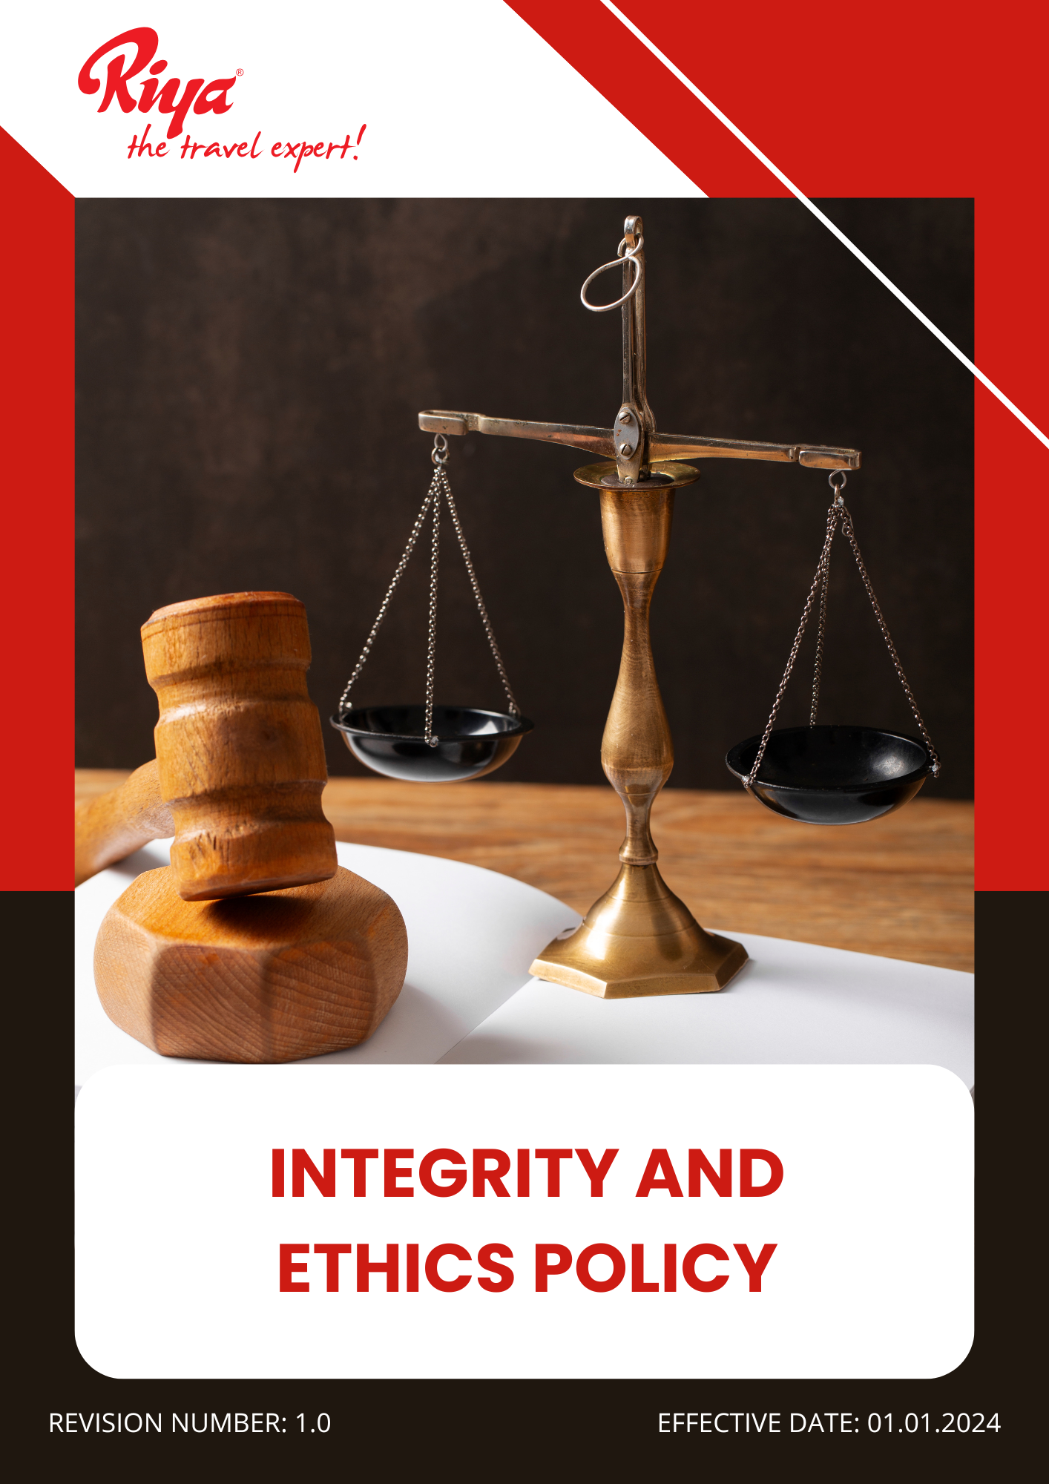

Contents
~ Overview 3
~ Purpose 3
~ Applicability 3
~ Our Focus Areas 4
~ Our Strategic Approach 4
~ Disciplinary Measures for Violations 6
~ Guidelines for Employees 7
~ Governance of this Policy 10
~ Responsibility for this Policy 10
~ Reporting 11
~ Continuous Improvement 11
~ Review Mechanism for this policy 12
~ Employee Acknowledgement Form 13

Overview
At Riya Travels and Tours Pvt Ltd (Group), we uphold the highest standards of integrity, transparency, and ethical conduct in all aspects of our business. As a trusted leader in the travel industry, we are committed to fostering a culture of honesty, accountability, and fairness among our employees, partners, and stakeholders. Our Integrity and Ethics Policy serves as a guiding framework for ethical decision-making, ensuring compliance with legal and regulatory requirements while promoting respect, inclusivity, and professionalism. We strictly prohibit corruption, bribery, and any form of unethical behavior, and we encourage open communication and responsible business practices. By adhering to these principles, we aim to build long-term trust with our customers and partners while maintaining our reputation as a responsible and ethical organization. This policy reinforces our commitment to ethical leadership, corporate responsibility, and a workplace culture that values integrity at every level of our operations.

Purpose
- Foster a culture of integrity and responsible leadership across all levels of the organization.
- Ensure compliance with local and international laws and regulations governing business operations.
- I Strengthen data privacy and protect confidential information to maintain stakeholder trust.
- Safeguard stakeholder interests by ensuring responsible governance and risk management.
- Prevent corruption, bribery, and conflicts of interest through strong internal controls and compliance mechanisms.
- Ensure transparency, accountability, and ethical conduct in all business operations and decision-making processes.
- Establish a whistleblower mechanism to enable employees and stakeholders to report unethical behavior without fear of retaliation.

Applicability
This Integrity and Ethics Policy is applicable across all operations, business functions, and services of Riya Travel and Tours (India) Pvt Ltd (Group), covering all global locations, including corporate offices, registered offices, branch locations, subsidiaries, joint ventures, and associated supply chain activities. It applies to all employees, workers, contractors, and stakeholders connected to Riya Travel and Tours (India) Pvt Ltd (Group), whether directly or indirectly, and mandates strict adherence and accountability at every level.

Our Focus Areas
- Ensuring transparency, accountability, and integrity in all business operations.
- Upholding ethical business practices and preventing corruption, bribery, and conflicts of interest.
- Strengthening internal controls and compliance with applicable laws and regulations.
- Promoting responsible decision-making at all levels of the organization.
- Safeguarding data privacy and protecting confidential information.
- Establishing clear guidelines for whistleblowing and addressing grievances.
- Ensuring diversity and inclusion in leadership and decision-making processes.

Our Strategic Approach
- Integrity-Driven Anti-Corruption Measures
- We aim to maintain zero reported cases of corruption by FY 2027-28 by strengthening internal controls, enhancing employee awareness.
- We will implement a comprehensive anti-corruption training program to raise awareness and strengthen ethical practices, targeting 100% workforce participation by FY 2027-28 from the baseline year FY 2022-23.
- Employees will be provided with clear guidelines on ethical decision-making and how to report corruption-related concerns without fear of retaliation.
- A comprehensive corruption risk assessment will be conducted annually across 100% of business units and supplier networks to identify and mitigate risks, ensuring full coverage by FY 2027-28.
- We will increase the number of internal audits on anti-corruption practices, targeting at least 2 audits annually across all locations by FY 2027-28 to strengthen compliance and identify potential risks.
- We will introduce an anti-corruption supplier audit program to assess and monitor compliance, aiming to audit 100% of Tier 1 suppliers and achieve 100% compliance with anti-bribery clauses by FY 2027-28.

- Managing Conflicts of Interest
- We aim to maintain zero cases of conflict of interest across all business operations started from baseline year FY 2022-23 through enhanced disclosure, training, and monitoring.
- We will establish clear conflict of interest guidelines to ensure transparent decision-making, requiring 100% of employees to disclose potential conflicts and adhere to ethical standards.
- We aim to establish a transparent work culture by encouraging disclosure of conflicts of interest among employees and stakeholders to maintain ethical practices, targeting 100% compliance by FY 2027-28 from the baseline year FY 2022-23.
- We strive to conduct training sessions to ensure employees can identify and address conflicts of interest, promoting integrity and decision-making, by FY 2027-28 from the baseline year FY 2022-23.
- We aim to incorporate conflict of interest checks into business decisions to enhance transparency and ensure fair outcomes, achieving full integration by FY 2027-28 from the baseline year FY 2022-23.
- Fraud Prevention
- We aim to establish a robust fraud prevention framework by promoting transparency and accountability across all business operations, targeting 100% compliance by FY 2027-28 from the baseline year FY 2022-23.
- We strive to conduct regular fraud prevention and awareness training sessions to ensure that 100% of employees can identify and report potential fraud cases, enhancing vigilance by FY 2027-28 from the baseline year FY 2022-23.
- We will implement a confidential whistleblowing mechanism to enable employees to report suspected fraud without fear, aiming for 100% employee covered in awareness sessions by FY 2027-28 from the baseline year FY 2022-23.
- We will ensure that all financial transactions and reporting processes are regularly audited to prevent misstatements and fraudulent activities, targeting 100% compliance by FY 2027-28 from the baseline year FY 2022-23.
- We plan to strengthen supplier vetting and contract reviews to minimize fraud risks by conducting comprehensive supplier background checks, ensuring 100% of suppliers undergo fraud screening by FY 2027-28 from the baseline year FY 2022-23.
- Anti-Money Laundering (AML) Compliance
- We aim to achieve zero cases of money laundering by strengthening internal controls and monitoring systems, targeting full compliance by FY 2027-28 from the baseline year FY 2022-23.
- A comprehensive Anti-Money Laundering (AML) policy will be implemented, ensuring 100% compliance with local and international regulations by FY 2027-28.
- Advanced transaction monitoring systems will be deployed to detect and flag suspicious activities in real time, with a goal of reducing AML-related risks by 50% from the baseline year FY 2022-23.
- Mandatory AML training programs will be conducted for all employees, ensuring 100% participation by FY 2027-28.
- Information Security
- We aim to maintain zero cases of data breaches starting from the baseline year FY 2022-23, ensuring full protection of sensitive information by FY 2027-28.
- We strive to conduct regular employee training on information security to ensure 100% awareness and adherence to best practices by FY 2027-28 from the baseline year FY 2022-23.
- We will implement multi-layered security measures, including encryption and access controls, to safeguard critical business information, aiming for zero data breaches by FY 2027-28 from the baseline year FY 2022-23.
- We aim to conduct periodic internal and external audits of our information security systems to identify and resolve vulnerabilities, achieving full compliance by FY 2027-28 from the baseline year FY 2022-23.
- We will ensure that all third-party vendors handling sensitive information comply with our security standards, targeting 100% vendor compliance by FY 2027-28 from the baseline year FY 2022-23.
- We plan to develop an incident response plan to effectively manage and mitigate security breaches, aiming for a 100% resolution rate within 48 hours by FY 2027-28 from the baseline year FY 2022-23.

Disciplinary Measures for Violations
To maintain integrity, violations of the Ethics Policy will be addressed through a structured disciplinary framework:
- Disciplinary Action: Employees found violating this policy will be subject to disciplinary measures, including formal warnings, suspension, or termination of employment, depending on the severity of the breach.
- Legal Action: Violations involving corruption, fraud, bribery, or money laundering may lead to legal action, including criminal prosecution and financial penalties, as per applicable local and international laws.
- Contract Termination: Business partners, suppliers, or contractors found in breach of this policy may face contract termination and removal from the company’s approved supplier list.
- Financial Penalties: Any financial loss incurred due to a breach of policy may be recovered from the responsible individuals or entities.
- Loss of Business Privileges: Individuals or entities involved in unethical behavior may face suspension or permanent loss of business privileges with Riya Travels and Tours Group.
- Reputation Damage and Corrective Action: Any damage to the company’s reputation due to unethical behavior will require corrective actions, including public disclosure and engagement with affected stakeholders.
- Whistleblower Protection and Investigation: All reports of policy violations will be promptly investigated under strict confidentiality. Retaliation against whistleblowers is strictly prohibited, and any such act will result in disciplinary action.
- Mandatory Retraining: Employees or partners found violating the policy may be required to undergo mandatory retraining on the company’s Integrity and Ethics Policy to prevent recurrence.

Guidelines for Employees
All employees, including those directly or indirectly associated with Riya Travels and Tours Pvt Ltd (Group), are expected to uphold the company’s core values of integrity, transparency, and ethical conduct. The following guidelines outline the expected standards of behavior and responsibility:
- Professional Conduct and Integrity
- Always be honest, respectful, and professional in all business dealings.
- Communicate clearly and truthfully with clients, colleagues, and partners.
- Treat all clients and colleagues with courtesy and professionalism, even in challenging situations.
- Avoid gossip, negative talk, and unprofessional language within the workplace.
- Respond to client complaints promptly and professionally, aiming to resolve issues fairly.
Example:
✅ If a client asks about a flight delay, honestly share the reason and possible solutions.
❌ Lying to the client to avoid complaints is not acceptable.
- Conflict of Interest Disclosure
- Avoid situations where personal interests could affect business decisions.
- Disclose any personal relationships or financial interests that may create a conflict.
- Do not use your position to benefit yourself, family, or friends at the company's expense.
Example:
✅ If your brother owns a travel agency, disclose this before recommending it to a client.
❌ Awarding a contract to your brother’s agency without informing the company is unethical.
- Confidentiality and Data Protection
- Keep client and company information private and secure.
- Do not share sensitive information with outsiders.
- Ensure that confidential documents are stored securely and accessed only by authorized personnel.
- Destroy sensitive data responsibly when it is no longer needed.
Example:
✅ If a client shares passport details for a booking, make sure it is stored securely.
❌ Sharing client information with a friend or competitor is a serious violation.
- Anti-Corruption and Anti-Bribery
- Do not offer or accept bribes, gifts, or favors to influence business decisions.
- Follow company guidelines on acceptable gifts and hospitality.
- Avoid any financial transactions that could be perceived as bribery.
- Report any attempts of bribery or corruption to the compliance team immediately.
Example:
✅ Accepting a small gift like a pen from a supplier during a business event is okay.
❌ Accepting a luxury vacation from a supplier in exchange for a contract is not allowed.
- Fair and Transparent Business Practices
- Be clear and honest about service charges and terms with clients.
- Do not hide costs or mislead clients.
- Ensure that all contracts and agreements are written clearly and follow company policies.
- Avoid unfair competition or misleading advertising about company services.
Example:
✅ Informing a client about additional luggage fees before they book the ticket.
❌ Hiding extra charges and surprising the client later is dishonest.
- Reporting and Whistleblowing
- Report any unethical behavior or policy violations to the company.
- You will be protected from retaliation if you report honestly.
- Ensure that whistleblowing reports are handled confidentially and fairly.
Example:
✅ Reporting a colleague who is inflating travel expenses to the compliance team.
❌ Ignoring the issue because you are afraid of consequences is not acceptable.
- Ethical Handling of Financial Transactions
- Ensure that all financial transactions are accurate and properly documented.
- Do not submit false or misleading financial information.
- Expense claims must be accurate and supported by valid documentation.
- Report any suspicious financial activity to the finance or compliance team.
Example:
✅ Submitting an expense claim with proper receipts and details.
❌ Claiming reimbursement for a personal expense as a business expense is fraud.
- Ethical Handling of Client and Supplier Relationships
- Treat clients and suppliers fairly and professionally.
- Select suppliers based on quality and value, not personal connections.
- Do not engage in side deals or private agreements with suppliers.
- Ensure that supplier contracts comply with company policies and legal requirements.
Example:
✅ Choosing a supplier because they offer the best service and price.
❌ Choosing a supplier because they are a friend or relative is not ethical.
- Compliance with Laws and Regulations
- Follow all applicable local and international laws.
- Report any illegal or non-compliant activity immediately.
- Stay informed about changes in laws and regulations that affect business operations.
Example:
✅ Ensuring all visa applications are processed according to immigration laws.
❌ Forging documents to bypass visa requirements is illegal and unethical.

Governance of this Policy
The governance of this Integrity and Ethics Policy will be overseen by the Ethics and Compliance Officer. This individual will be responsible for ensuring adherence to ethical standards, monitoring compliance with legal and regulatory requirements, and addressing any ethical concerns within the organization. They will work closely with all departments to promote a culture of integrity, provide training on ethical conduct, and facilitate open communication regarding ethical dilemmas. Regular audits, reporting mechanisms, and policy updates will be conducted to maintain transparency and accountability. The Ethics and Compliance Officer will ensure that ethical principles remain central to corporate decision-making and business operations.

Responsibility for this Policy
- Ethics and Compliance Officer
- Responsible for overseeing and review the implementation of the policy.
- Tracking ethical compliance progress and reports misconduct issues.
- Implements training programs and best practices to foster an ethical work culture.
- Senior Management
- Provides leadership and reinforces ethical values within corporate decision-making.
- Allocates necessary resources to maintain compliance and prevent unethical practices.
- Employees
- Expected to uphold ethical standards, act with honesty, and report any unethical behavior.
- Participate in ethics training and comply with company policies and legal obligations.
- Human Resources (HR) Department
- Ensures fair treatment of employees and handles ethical concerns within the workplace.
- Implements procedures to address complaints and misconduct transparently.
- Legal and Compliance Team
- Ensures the organization complies with all relevant laws and regulations.
- Provides guidance on ethical issues and risk mitigation strategies.

Reporting
- Internal Reporting
- The Ethics and Compliance Officer will submit quarterly reports on policy adherence, ethical concerns, and corrective measures taken.
- HR and department heads will provide updates on ethical training, employee concerns, and policy improvements.
- Compliance Reporting
- Regular audits will be conducted to identify potential ethical risks and non-compliance issues.
- Any ethical violations will be documented, investigated, and addressed promptly.
- External Reporting
- An annual Ethics and Compliance Report will be published to highlight the company’s commitment to integrity and transparency.
- Reports will be shared with regulatory bodies, stakeholders, and business partners as required.
- Employee and Stakeholder Feedback
- A confidential reporting channel will be available for employees and stakeholders to report ethical concerns.
- Feedback will be reviewed regularly to enhance the effectiveness of the policy.

Continuous Improvement
We are committed to continuously strengthening our integrity and ethical standards. Our policies and ethical guidelines will be regularly assessed to incorporate best practices, legal updates, and stakeholder expectations. Through ongoing ethics training, enhanced reporting mechanisms, and a culture of accountability, we will ensure ethical conduct remains a core pillar of our business operations.

Review Mechanism for this policy
The Ethics and Compliance Officer will review this policy every year or as needed to ensure it remains effective and up to date. In collaboration with senior management and relevant stakeholders, they will monitor adherence, address emerging ethical challenges, and refine policies to align with evolving legal and corporate governance requirements. Necessary adjustments will be implemented to maintain transparency, fairness, and integrity across all business operations.
Effective Date: 01.01.2024
Last Review Date: 01.01.2025
Next Review Date: 01.01.2026

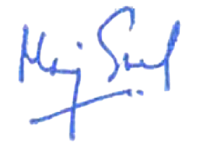

Approved By – Director HR
(Riya Travels and Tours (India) Pvt ltd (Group))

Employee Acknowledgement Form
I acknowledge that I have received, read, and understood the Integrity and Ethics Policy. I understand my responsibility to comply with the policy’s guidelines and to uphold the highest standards of integrity, honesty, and ethical conduct in all business activities. I commit to maintaining transparency, fairness, and accountability in my professional conduct while adhering to legal and ethical standards. I also recognize that the policy will be reviewed periodically, and I will stay informed about any updates. By signing this form, I confirm my commitment to upholding the principles outlined in the policy.

Employee Name: Mr. Milind Kadam
Department: IT
Designation: Team Leader
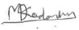
Date: 06/01/2025
Signature:

